Programming Fundamentals Lab FALL, 2022 NUCES, Islamabad

National University of Computer and Emerging Sciences Islamabad Programming

Fundamentals Lab FALL 2022

Lab Manual 08

**Function Overloading**

we will learn about the function overloading in C++ with examples.In C++, two functions can have the same name if the number and/or type of arguments passed is different.These functions having the same name but different arguments are known as overloaded functions. For example

// same name different arguments

int test() { }

int test(int a) { }

float test(double a) { }

int test(int a, double b) { }

Here, all 4 functions are overloaded functions. Notice that the return types of all these 4 functions are not the same. Overloaded functions may or may not have different return types but they must have different arguments. For example,

// Error code

int test(int a) { }

double test(int b){ }

Here, both functions have the same name, the same type, and the same number of arguments. Hence, the compiler will throw an error.

**Default Arguments (Parameters)**

In this tutorial, we will learn C++ default arguments and their working with the help of examples.

In C++ programming, we can provide default values for function parameters.

If a function is called without arguments, then the default parameters are used

However, if arguments are passed while calling the function, the default arguments are ignored.

Working of default arguments

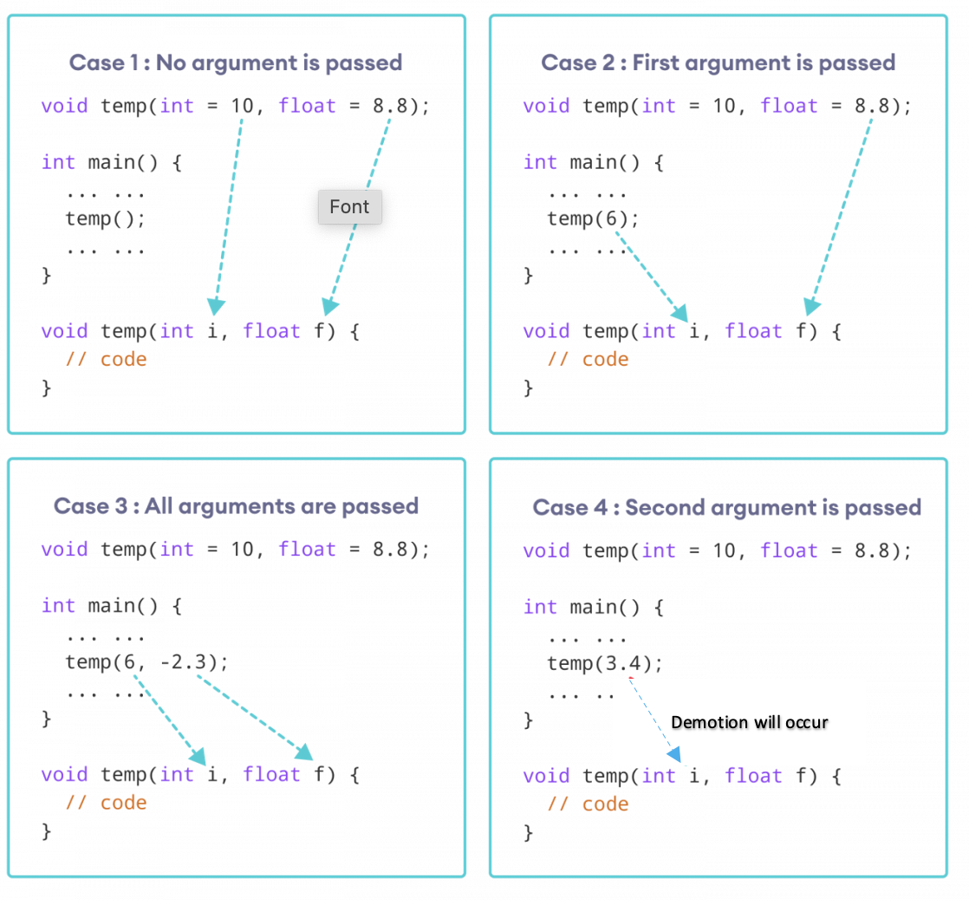

Demotion will occur

**LAB TASK**

1. Write a overloaded functions with same name area() for finding the Area of a circle, Area of triangle, Area of trapezium.

(Use function overloading)

2. The radius of the aorta is about 1.0 cm and the blood flowing through it has a speed of about 30 cms -1. Calculate the average speed of the blood in the capillaries using the fact that although each capillary has a diameter of about 8 x 10 -4 cm, there are literally millions of them so that their total cross section is about 2000 cm². (CPP code)

Hint: Use equation of continuity

(Create a function and default parameters)

|  |
| --- |
| **Submission Instructions:**  1.Save all **.cpp** files with your roll no and task number  **e.g. i22XXXX_Section_Task08.cpp**   1. Now create a new folder/directory with name *ROLLNO_SECTION_LAB05*   **e.g. i22XXXX_ Section_LAB08**   1. Move all of your .cpp files to this newly created directory and compress it into **.zip file**. 2. Now you have to submit this zipped file on Google Classroom. |

**THE END**